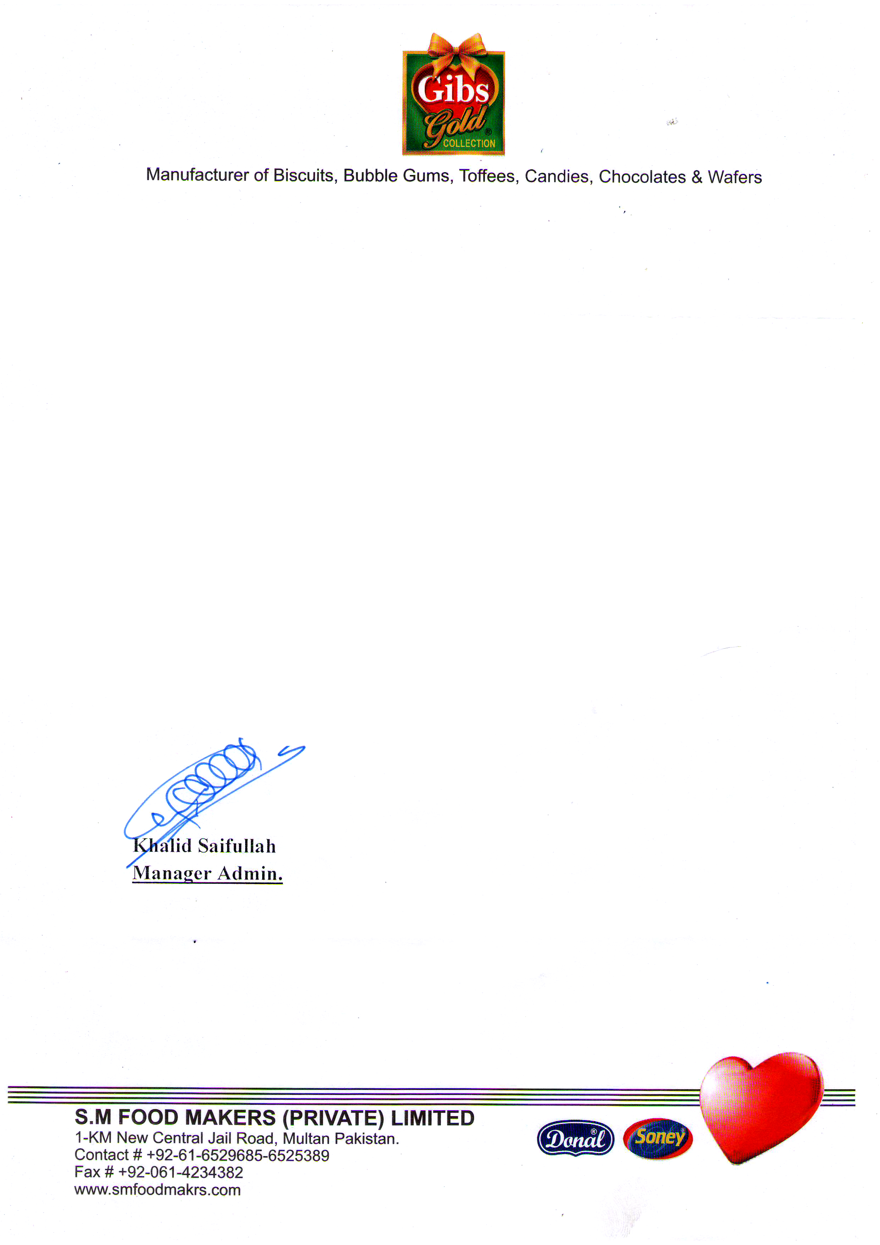

Date: <To2>

**TO WHOM IT MAY CONCERN**

It is certified that Mr. <Name> S/O <fname> CNIC No. <CNIC> in our organization as Purchase <Designation> from <From2> to <To2>.

During Service we found him hard working and professionally sound.

We wish him great success in his future.